H.T No
Regulations:
A22

Sreenidhi Institute of Science and Technology
(An Autonomous Institution)
Code No: 9AC48 Date: 30-Aug-2023 (FN)

B.Tech I-Year II- Semester External Examination, Aug/Sept-2023 (Regular)
BASIC ELECTRICAL AND ELECTRONICS ENGINEERING (CSE, IT, DS, CS, AIML and IOT)

Time: 3 Hours Max.Marks:60

Note: a) No additional answer sheets will be provided.
b) All sub-parts of a question must be answered at one place only, otherwise it will not be valued.
c) Missing data can be assumed suitably.
Bloom's Cognitive Levels of Learning (BCLL)

Remember | L1 | Apply | L3 | Evaluate | L5
Understand | L2 | Analyze | L4 | Create | L6

Part - A Max.Marks: 6x2=12

Answer all QUESTIONS, EACH QUESTION CARRIES 2 MARKS.

 |  | BCLL | CO(s) | Marks
1 | What is the purpose of commutator in DC Machine? | L1 | CO1 | [2M]
2 | Write the relation between phase voltage and line voltage, phase current and line current in the case of star connection and delta connection. | L1 | CO2 | [2M]
3 | What are the different types of measuring instruments? | L1 | CO3 | [2M]
4 | Draw the characteristics of PN junction diode. | L2 | CO4 | [2M]
5 | Distinguish between FET and BJT. | L2 | CO5 | [2M]
6 | Write the truth table for NAND gate for two inputs and draw its symbol. | L2 | CO6 | [2M]

Part – B Max.Marks: 6x8=48
ANSWER ALL QUESTIONS. EACH QUESTION CARRIES 8 MARKS.

 |  |  | BCLL | CO(s) | Marks
7. | a) | Calculate the current flowing in 6Ω resistor using mesh analysis.  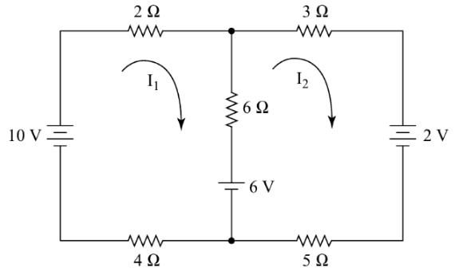 | L3 | CO1 | [8M]
 |  | OR
 | b) | Explain the operation of DC generator with neat sketch | L2 | CO1 | [8M]
8. | a) | A voltage v(t) = 100sin314t is applied to a series circuit consisting of 10 ohms resistance, 0.0318 Henry inductance and a capacitor of 63.6μF. Determine Impedance, power factor and active power consumed. | L3 | CO2 | [8M]
 |  | OR
 | b) | Write the equations of start to delta conversion and delta to start conversion with neat diagrams. | L4 | CO2 | [8M]
9. | a) | Explain the principle and construction of a PMMC instrument with the help of a neat sketch. | L2 | CO3 | [8M]
 |  | OR
 | b) | Explain the operation of 3-phase induction motor with neat sketch. | L2 | CO3 | [8M]
10. | a) | Explain clipper and clamping circuits | L4 | CO4 | [8M]
 |  | OR
 | b) | Draw the V-I characteristics of Zener diode and what are the differences between an ordinary semiconductor diode and zener diode. | L2 | CO4 | [8M]
11. | a) | Compare CB, CE and CC configurations | L4 | CO5 | [8M]
 |  | OR
 | b) | Explain the construction and working of a n-channel JFET | L2 | CO5 | [8M]
12. | a) | 1010111011₍₂₎ convert into  i) Decimal ii) Octal  iii) Hexadecimal iv) 7864₍₁₀₎ convert into binary. | L4 | CO6 | [8M]
 |  | OR
 | b) | Obtain (i) Sum of products form and (ii) Product of sums form for  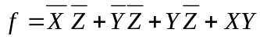 | L4 | CO6 | [8M]

-- 00 -- 00 –

